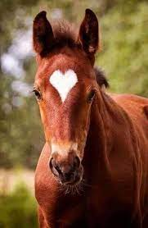

JJK Who’s Your Daddy Stallion Stakes

2023 Stallion Nomination form
Stallion's Registered Name: _______________________
Registration #: ____________Stud Fee:______________
Stallion Owner's Name: ________________________
Stallion Owner's Address: ___________________________________
Stallion Owner's Phone Number: ______________________________
Stallion Owner's Signature___________________________________
Email address: ____________________________________________
Website: _________________________________________________
Additional stallion information _________________________________
_________________________________________________________
Please include:

$100 nomination fee---payable to JJK Barrel Racing, LLC

Send to:
Juli Jo Kelly
Box 188, Ulm, MT 59485

406-866-2309 (home phone)
Jkbarnofbulldogs@aol.com (email)

